4] (a)

#include <stdio.h>

#include <string.h>

int main(){

char str1[100]="Hello ";

char str2[]="World";

strcat(str1,str2);

printf("Concatenated: %s\n",str1);

return 0;

}

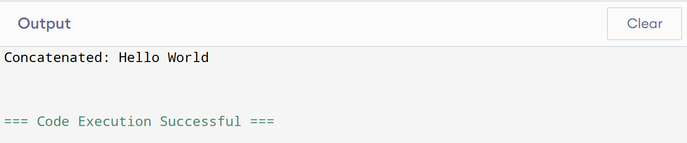

(b)

#include <stdio.h>

#include <string.h>

int main(){

char str[]="Hello";

int len=strlen(str);

for (int i=0;i<len/2;i++){

char temp=str[i];

str[i]=str[len-1-i];

str[len-1-i]=temp;

}

printf("Reversed: %s\n",str);

return 0;

}

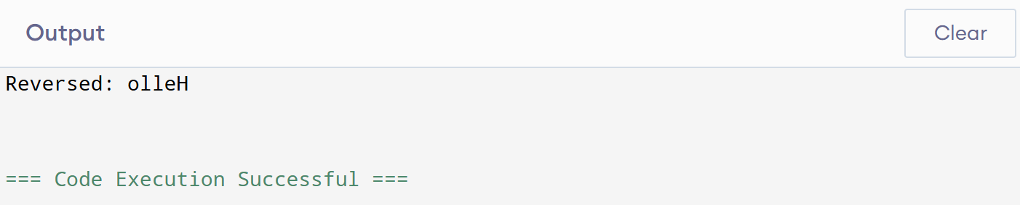

(c)

#include <stdio.h>

int main(){

char str[]="Wonderful";

char result[100];

int j=0;

for (int i=0;str[i]!='\0';i++){

char ch=str[i];

if (ch!='a'&&ch!='e'&&ch!='i'&&ch!='o'&&ch!='u'&&ch!='A'&&ch!='E'&& ch!='I'&&ch!='O'&&ch!='U'){

result[j]=ch;

j++;

}

}

result[j]='\0';

printf("Without vowels: %s\n",result);

return 0;}

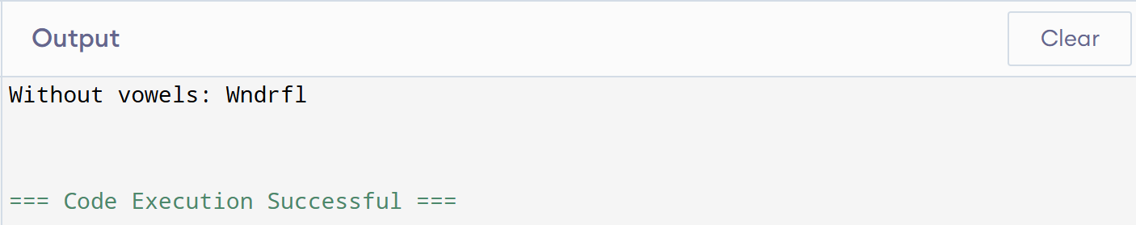

(d)

#include <stdio.h>

#include <string.h>

int main(){

char str[3][20]={"banana","apple","grape"};

char temp[20];

for(int i=0;i<3-1;i++){

for(int j=i+1;j<3;j++){

if (strcmp(str[i],str[j])>0){

strcpy(temp,str[i]);

strcpy(str[i],str[j]);

strcpy(str[j],temp);

}

}

}

printf("Sorted strings:\n");

for(int i=0;i<3;i++)

printf("%s\n",str[i]);

return 0;

}

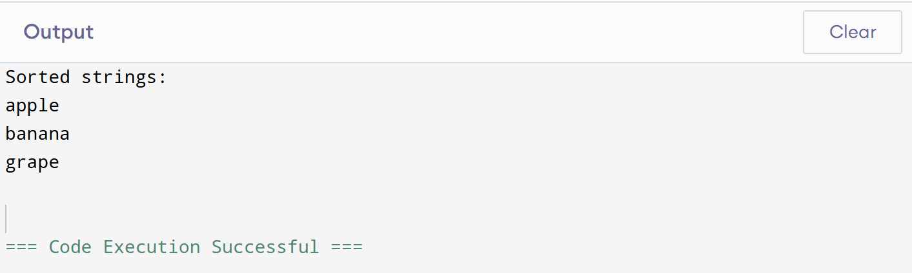

(e)

#include <stdio.h>

int main(){

char ch;

printf("Enter an uppercase letter: ");

scanf("%c",&ch);

if(ch>='A'&&ch<='Z'){

ch=ch+32;

printf("Lowercase: %c\n",ch);

}else{

printf("Not an uppercase letter!\n");

}

return 0;

}

